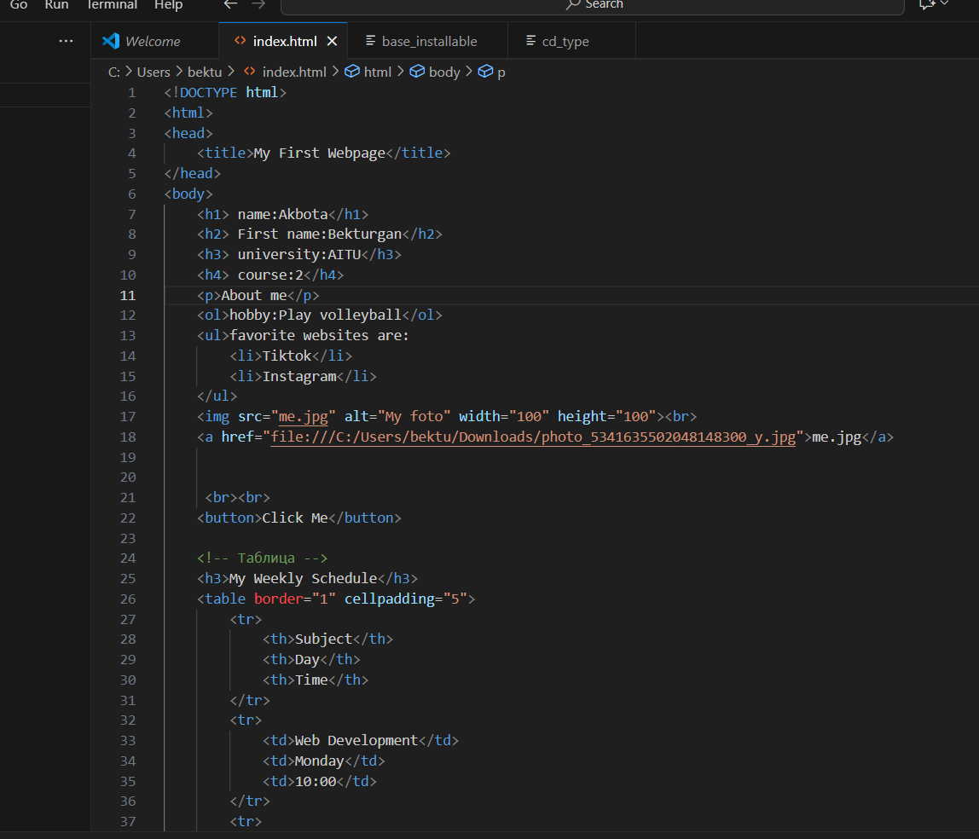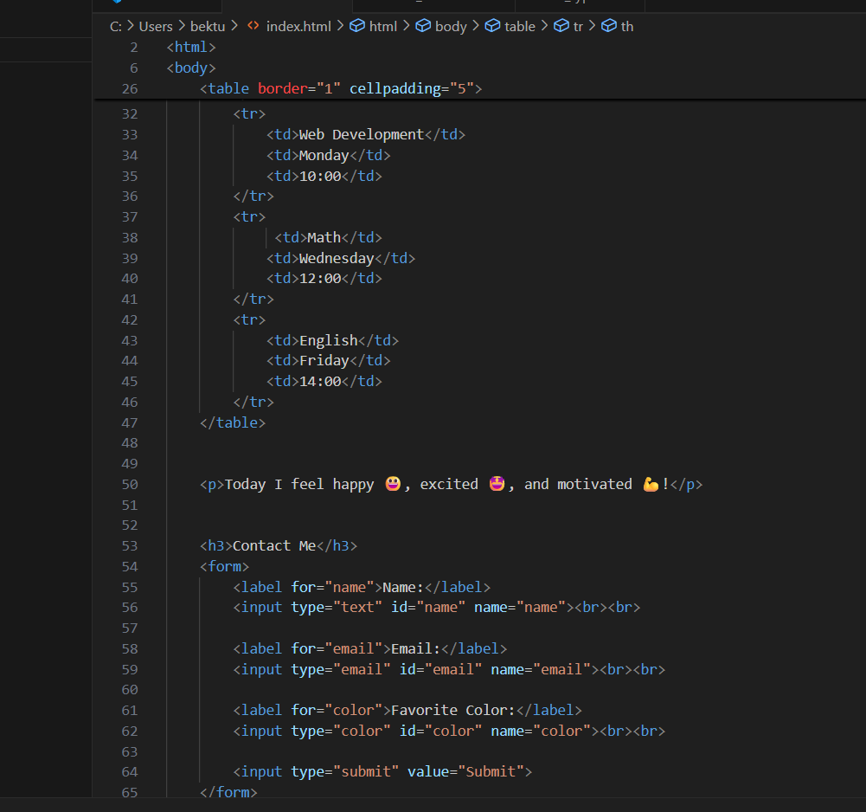

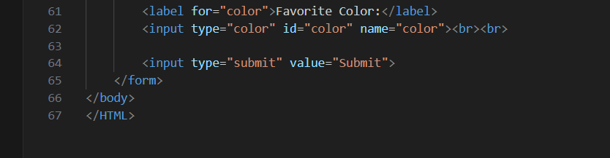

**Report on "My First Webpage"**

**Introduction**

This project is a simple HTML webpage created to practice basic web development skills. The page shows personal information, hobbies, favorite websites, an image, a schedule table, emotions, and a contact form. It demonstrates the use of main HTML tags.

**Structure of the Webpage**

1. **Headings (h1–h4)** – used to show name, first name, university, and course.
2. **Paragraph (p)** – gives short description "About me".
3. **Lists (ol, ul)** – shows hobby in ordered list and favorite websites in unordered list (TikTok, Instagram).
4. **Image (img)** – displays a photo with width and height set to 100 pixels.
5. **Hyperlink (a)** – links to a local photo file.
6. **Button (button)** – simple clickable button.
7. **Table (table)** – presents weekly schedule with three subjects: Web Development, Math, and English.
8. **Text with Emojis** – shows feelings: happy, excited, motivated.
9. **Form (form)** – allows user to enter name, email, favorite color, and submit.

**Purpose**

The webpage helps to understand the basics of HTML structure:

* how to use headings and text,
* how to insert images and links,
* how to make lists and tables,
* how to create simple forms for input.

**Conclusion**

The project shows a good first step in web development. It combines many HTML elements in one page and can be improved later with CSS for design and JavaScript for interaction. The work demonstrates knowledge of HTML fundamentals and personal creativity.